ECOR 1010 – DAY 11 & 12
Statistics
- Statistics are numbers that we use to describe many measurements.
- Depending on what is being measured some statistics are of no real value. Ex: Avg temp between a cold and hot water.

Arithmetic Average(mean)
- Mode is a statistic used to indicate the most probable measurement.
- The sum of all the data divided by the number of data points.

Median
- The value of the data points in the centre of the data set when arranged in ascending/descending order.
- E.g: 2.98,3.18,3.25, and 3.74. has a median of 3.25
- IF there is an even number of points, the median is the mean of the 2 centre data points.
- E.g., 2,3,6,7,12,15 > Median of (6+7)/2=6.5

Mode
- Mode is one or more sets of numbers that occurs with the greatest frequency
- E.g., 2,2,5,7,9,9,9,10,10,11,12,18 > Mode is 9
- E.g., 2,3,4,4,4,5,5,7,7,7,9 > Mode is 4 and 7

Histograms
- Valuable statistical tool for showing the frequency distribution of data
- If the probability of outliers is high, the Median is accurate while the mean and mode aren’t
Standard Error
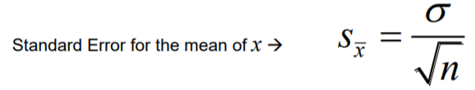
Where S_{x} = the Standard Deviation
And N = Sample Size

We don’t usually know the true standard deviation of the parent population(O) so, we estimate vv
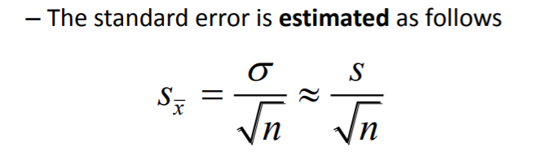
What the point?
- Almost all of our measurements are made with instruments that give us “average values”
- If you take many measurements and plot a histogram of these values, then you will get a normal distribution
- If we only do one N5, or one N20, measurement then we will have an estimate of the true mean, based on 1 sample.
- The single N5 or N20 measurement distribution will also have a width, which we can calculate as the standard deviation S.
- From the standard deviation(S), we calculate the standard error = S=S/root(N)
- We can never be 100% confident that the mean of the sample is the true mean

Common Confidence Values
‘True value’ = measures mean value + Z_{c}O measured where
Z_{c} = confidence level
Z₉₀ = 1.645 for 90% confidence
Z₉₉ = 2.58 for 99% confidence
